Write a program that determines if a person is eligible to vote based on their age

#include <iostream>

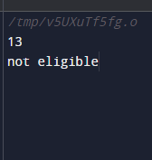using namespace std;

int main() {

int age;

cin>>age;

if (age>18)

{cout<<"eligible";}

else

{cout<<"not eligible";}

return 0;

}

Write a program that takes an integer as input and checks if it falls within the range

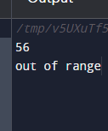#include <iostream>

using namespace std;

int main() {

int x;

cin>>x;

if (x>10&&x<50)

{cout<<"with in range";}

else

{cout<<"out of range";}

return 0;

}

Write a C++ program to compare two integers and find the maximum value.

#include <iostream>

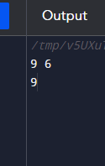using namespace std;

int main() {

int x,y;

cin>>x>>y;

if (x>y)

{cout<<x;}

else

{cout<<y;}

return 0;

}

Write a C++ program to calculate the average of three exam scores and determine if it's above a passing grade

#include <iostream>

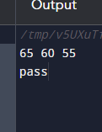using namespace std;

int main() {

int exam1,exam2,exam3, average;

cin>>exam1>>exam2>>exam3;

average= (exam1+exam2+exam3)/3;

if (average>=60)

{cout<<"pass";}

else

{cout<<"fail";}

return 0;

}